Name: Nam Jun Lee

WSU ID: 011606459

Assignment: Assignment #2

Class number: 2021 Fall-MIS-325-ONLIN-2217-H72-01-10356-LEC

Date: October 28th, 2021

<https://cb-ot-devst06.ad.wsu.edu/MF13namjun.lee/Assignment2/Assignment2.aspx>

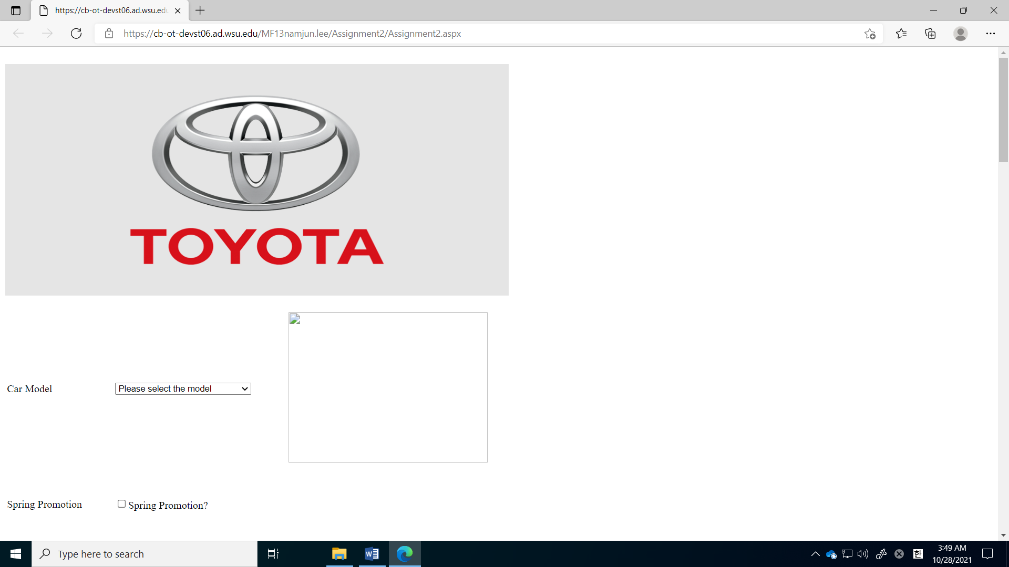

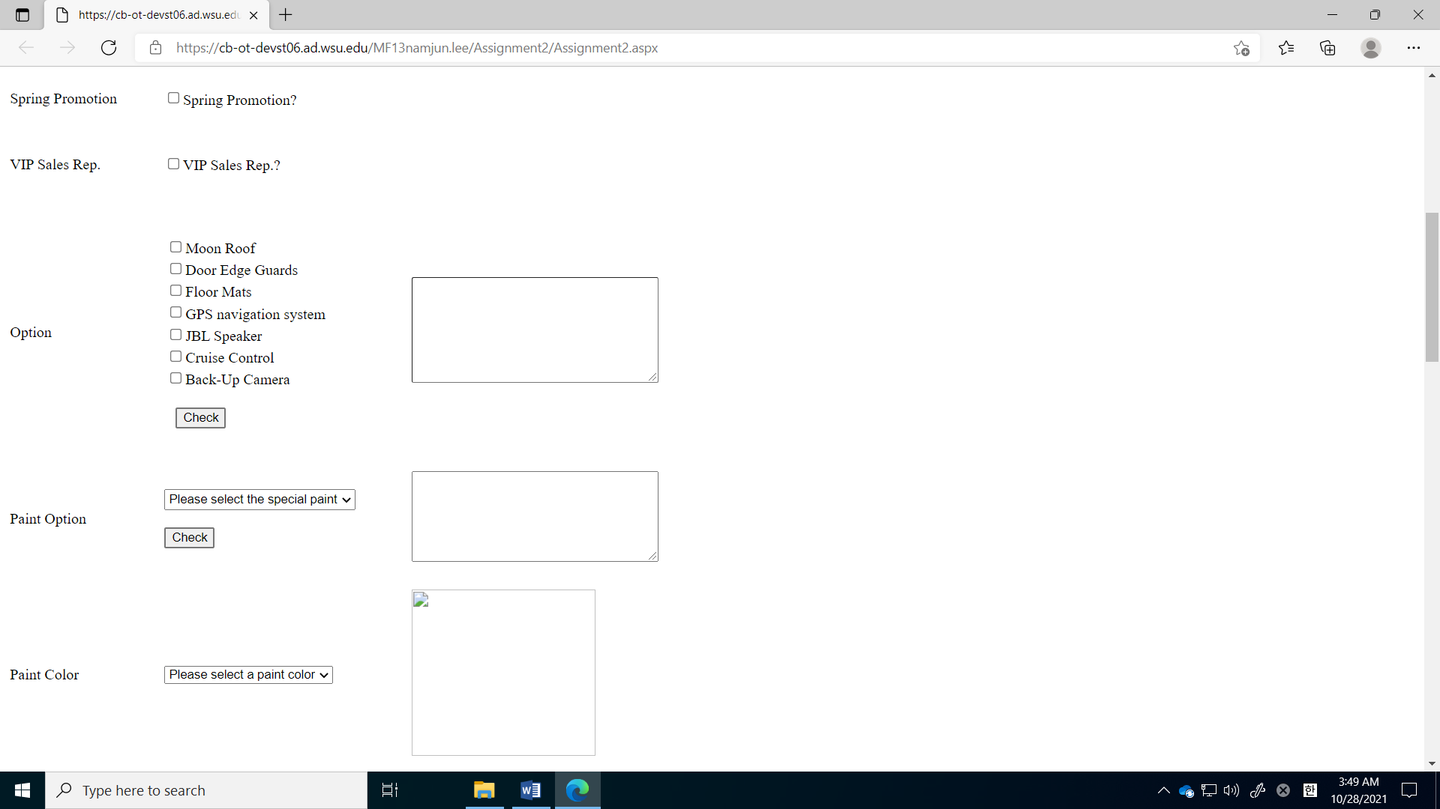

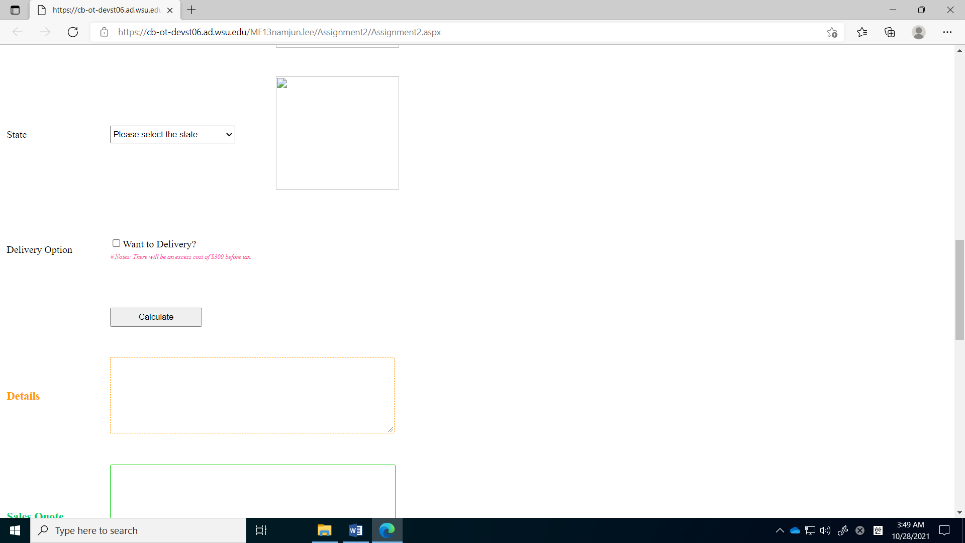

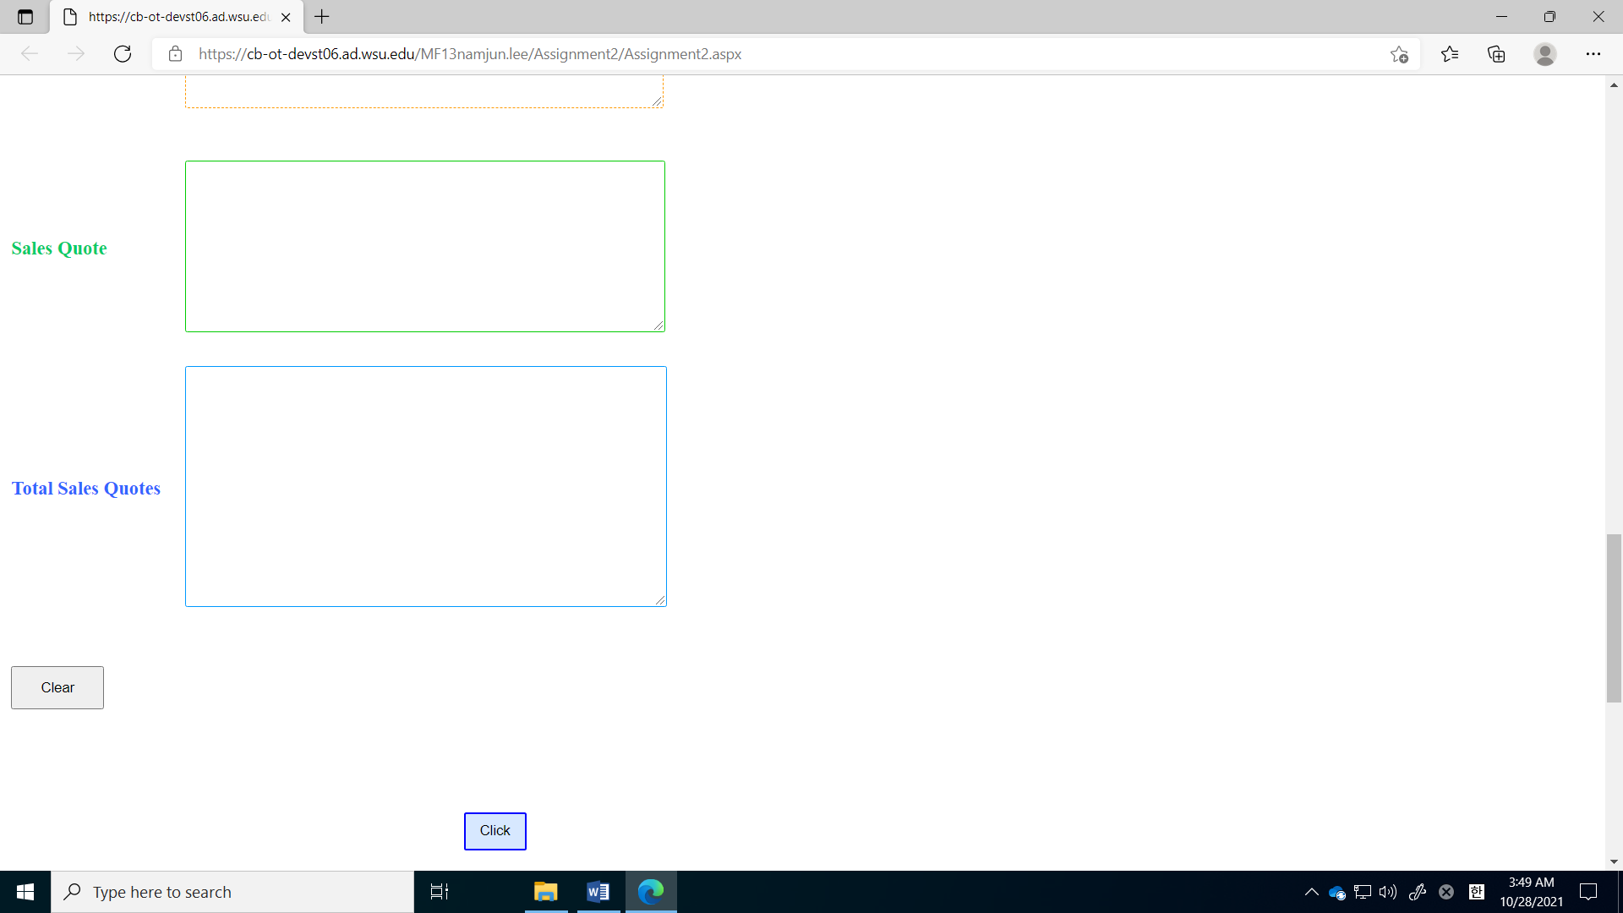

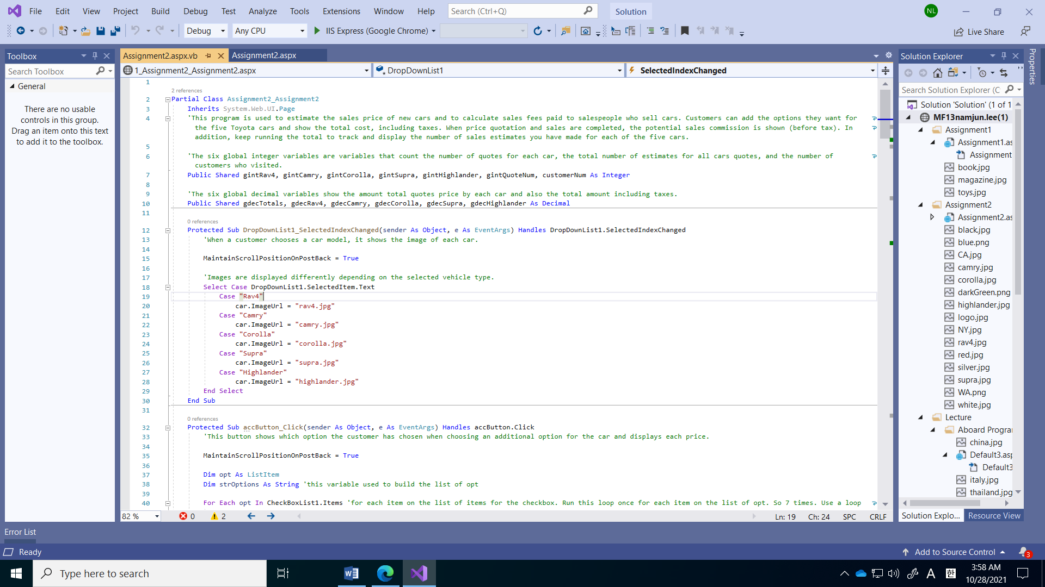

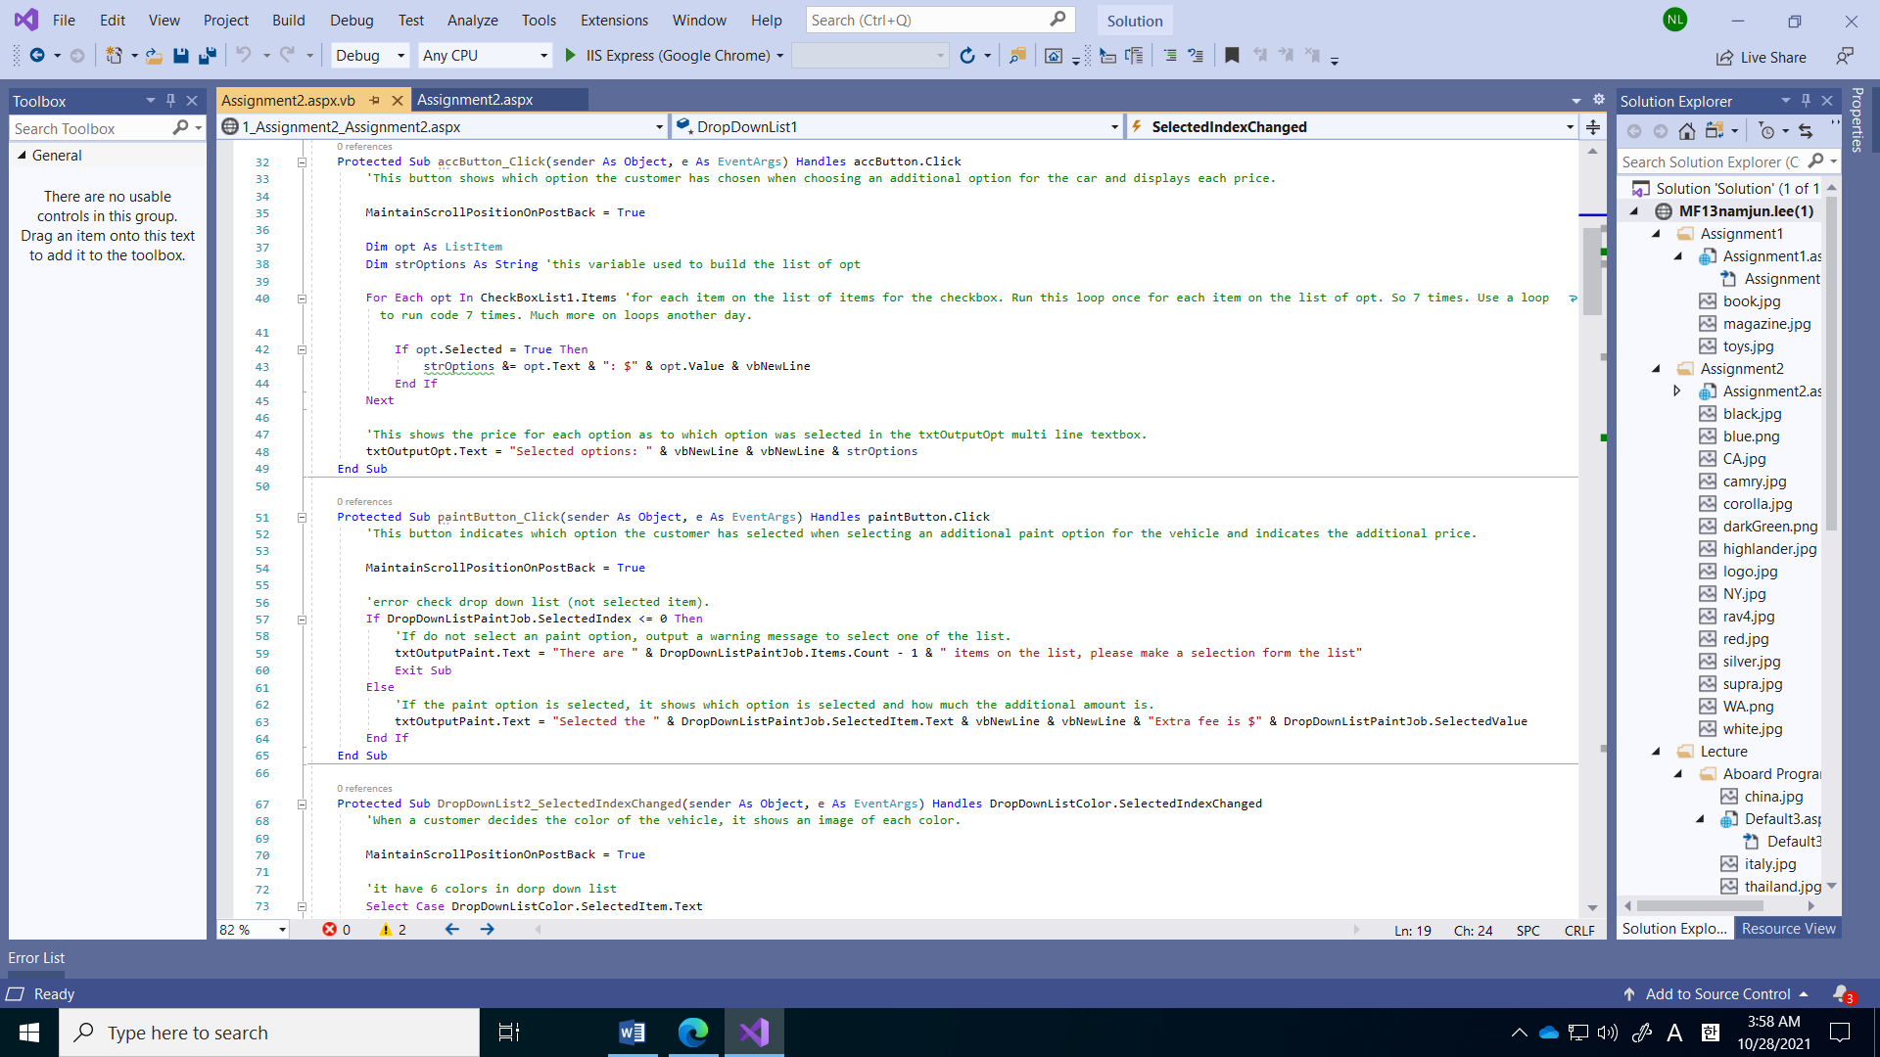

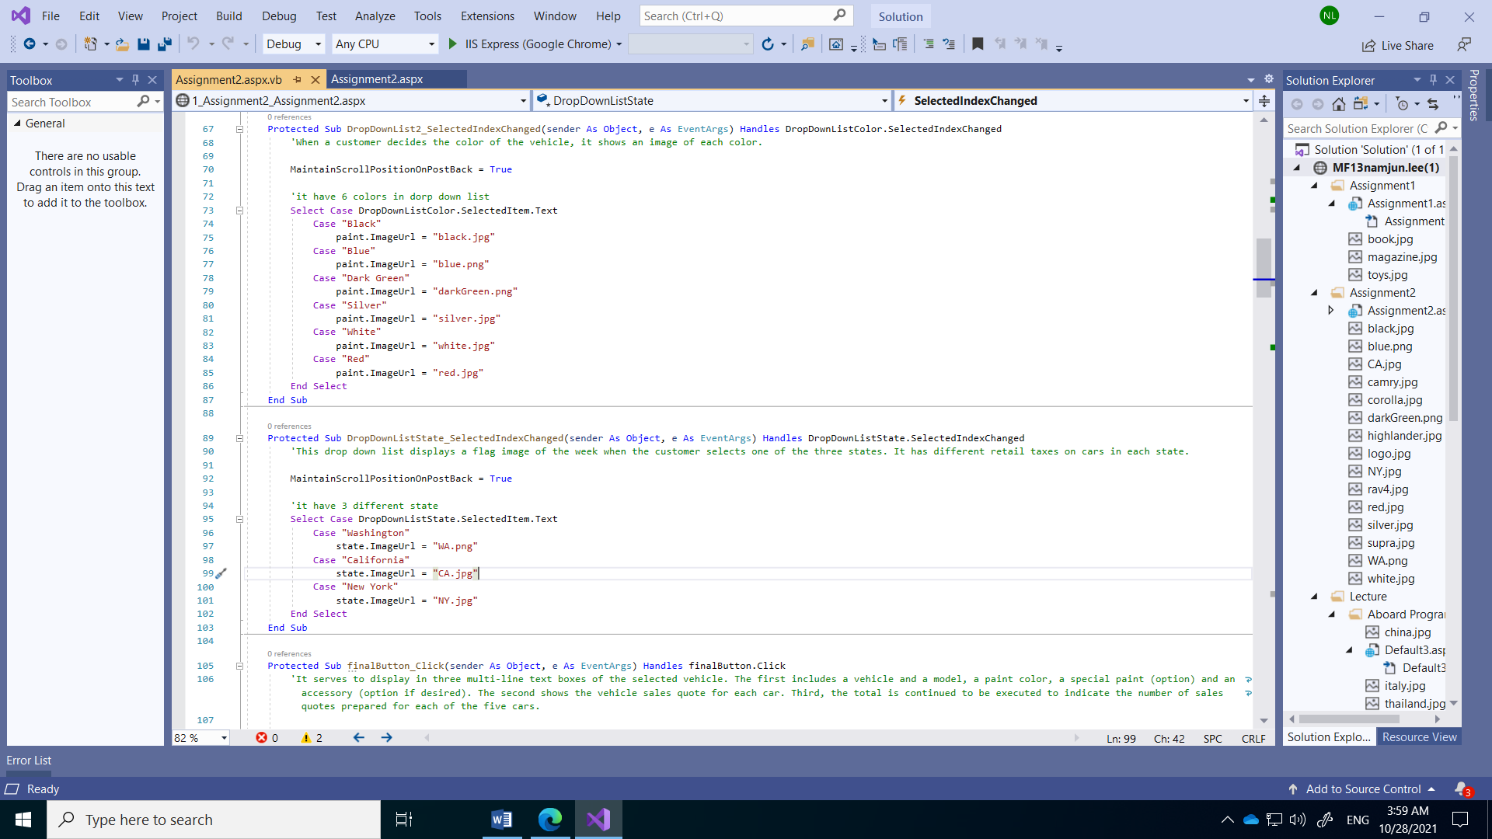

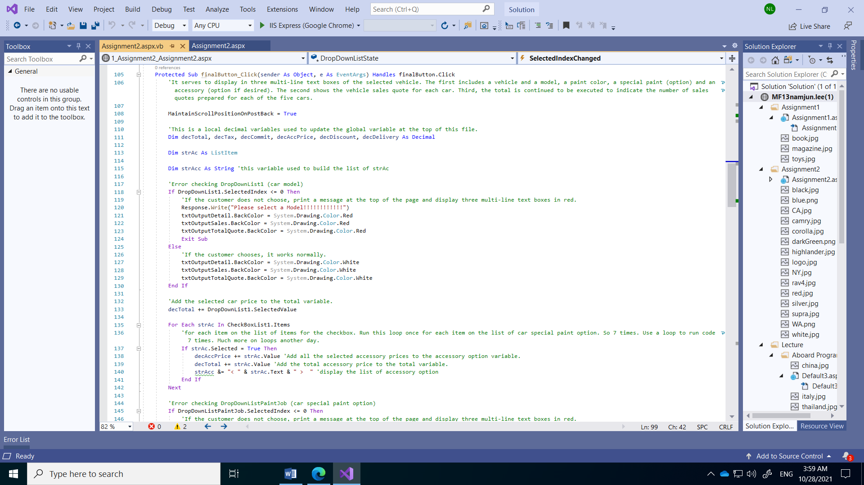

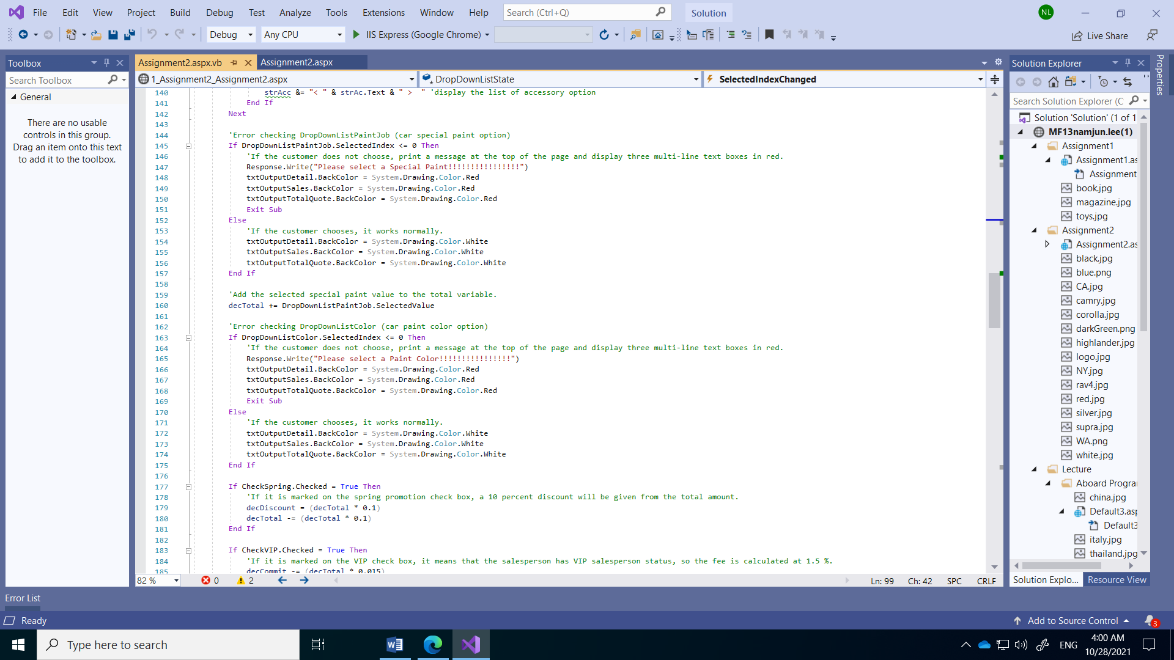

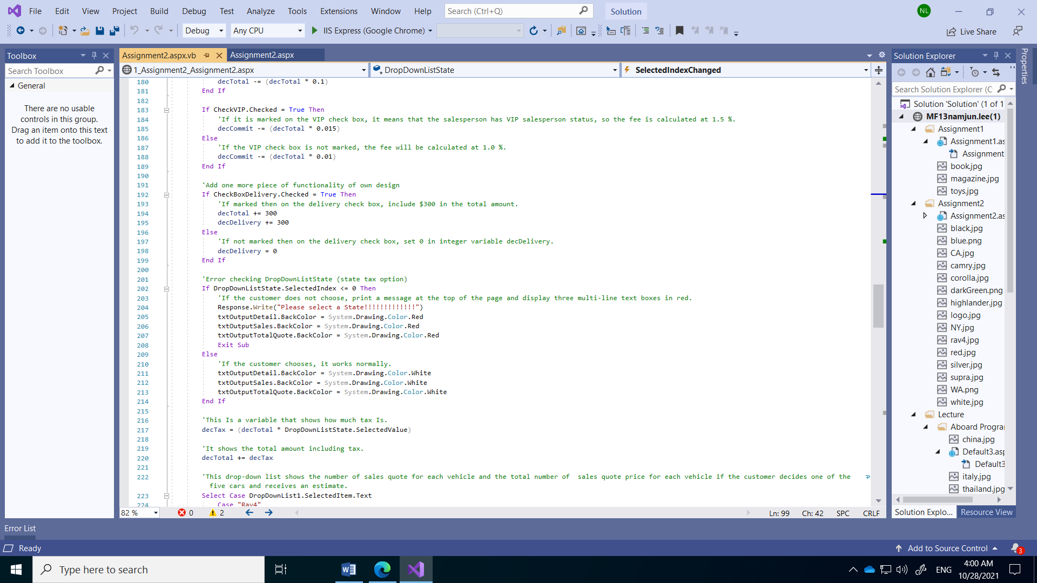

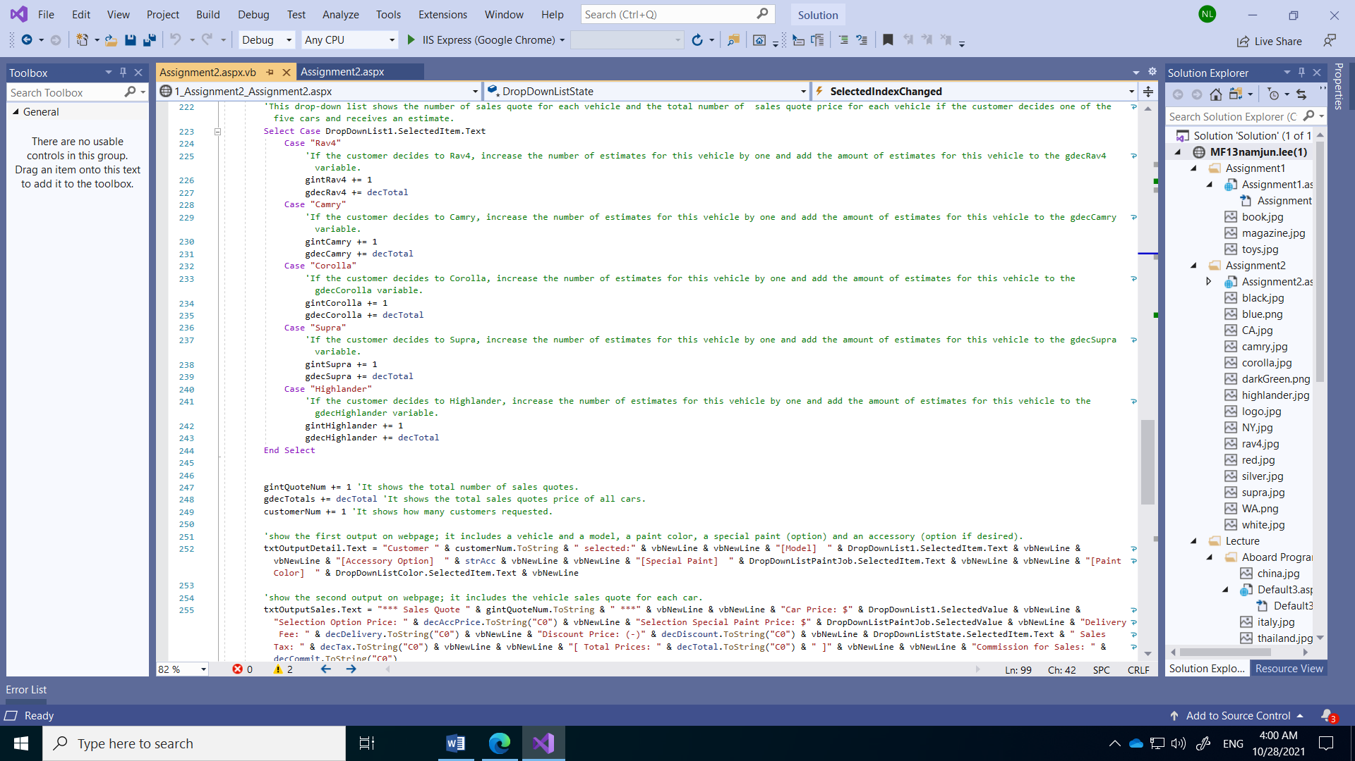

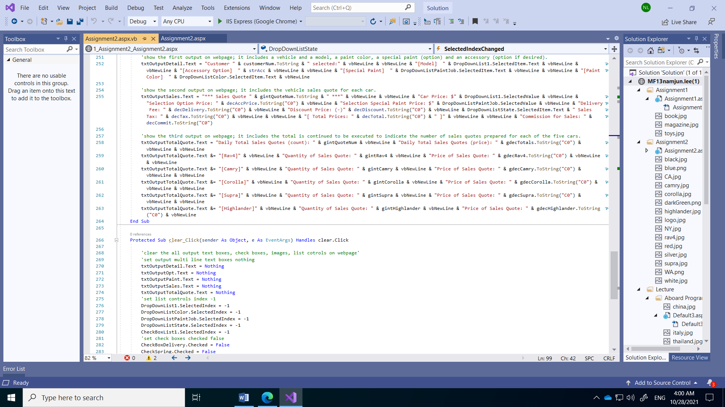

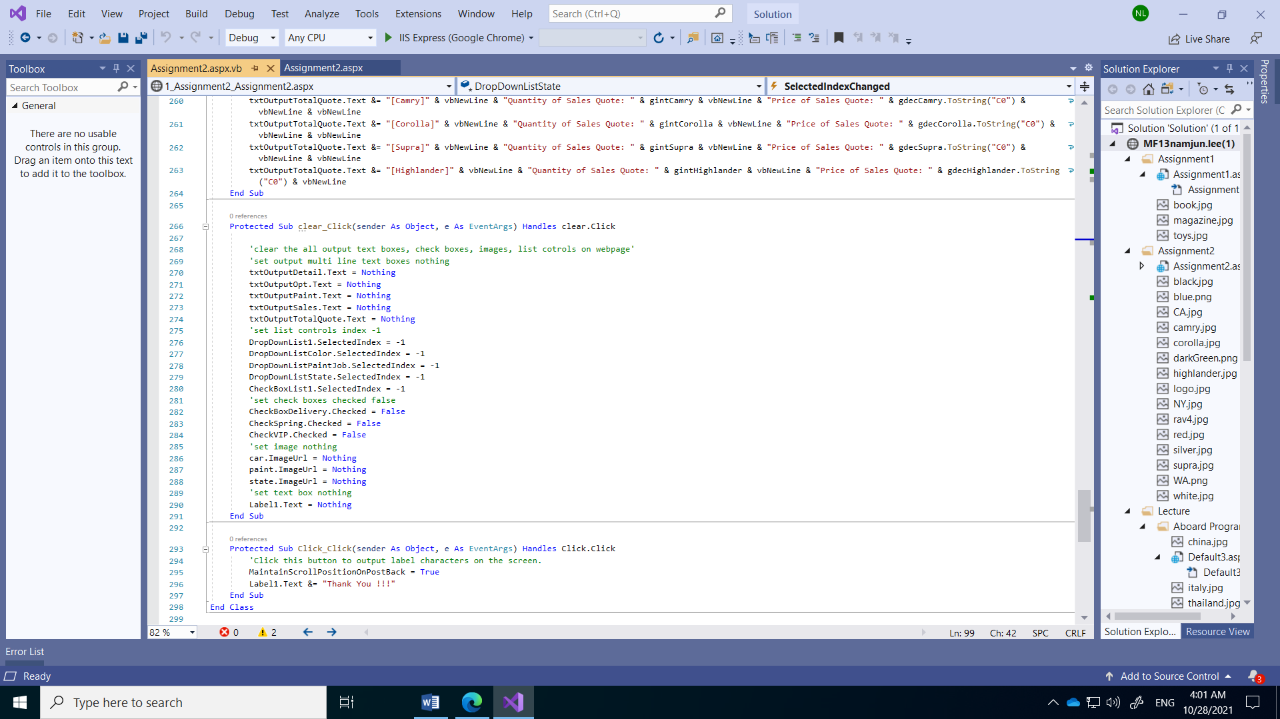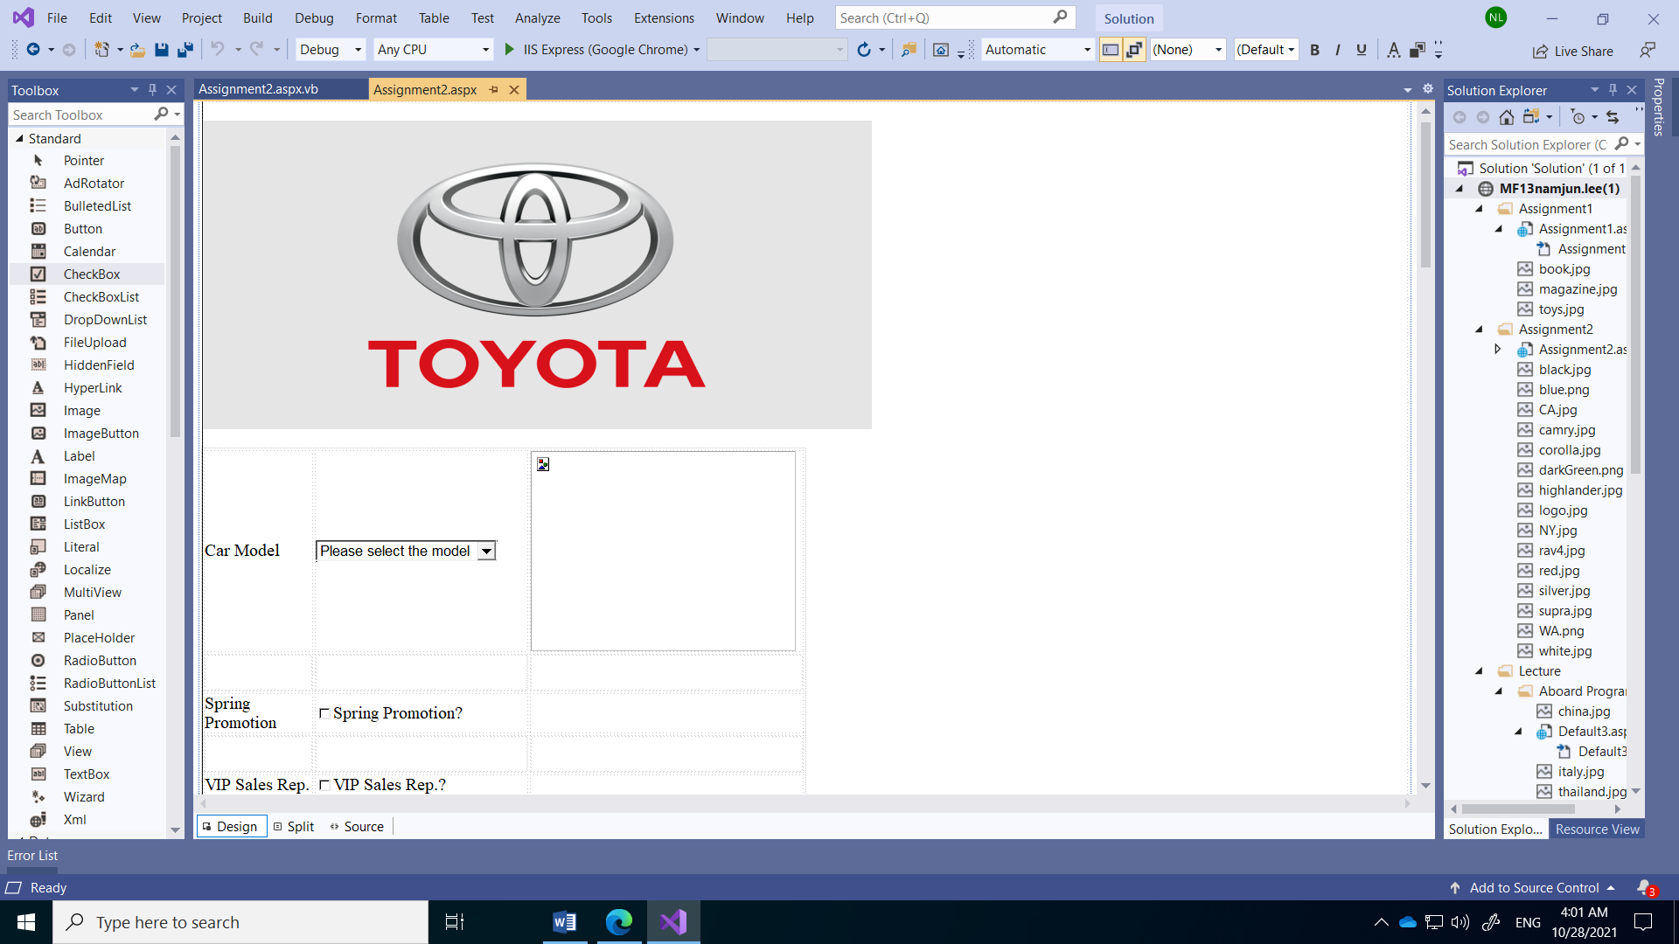

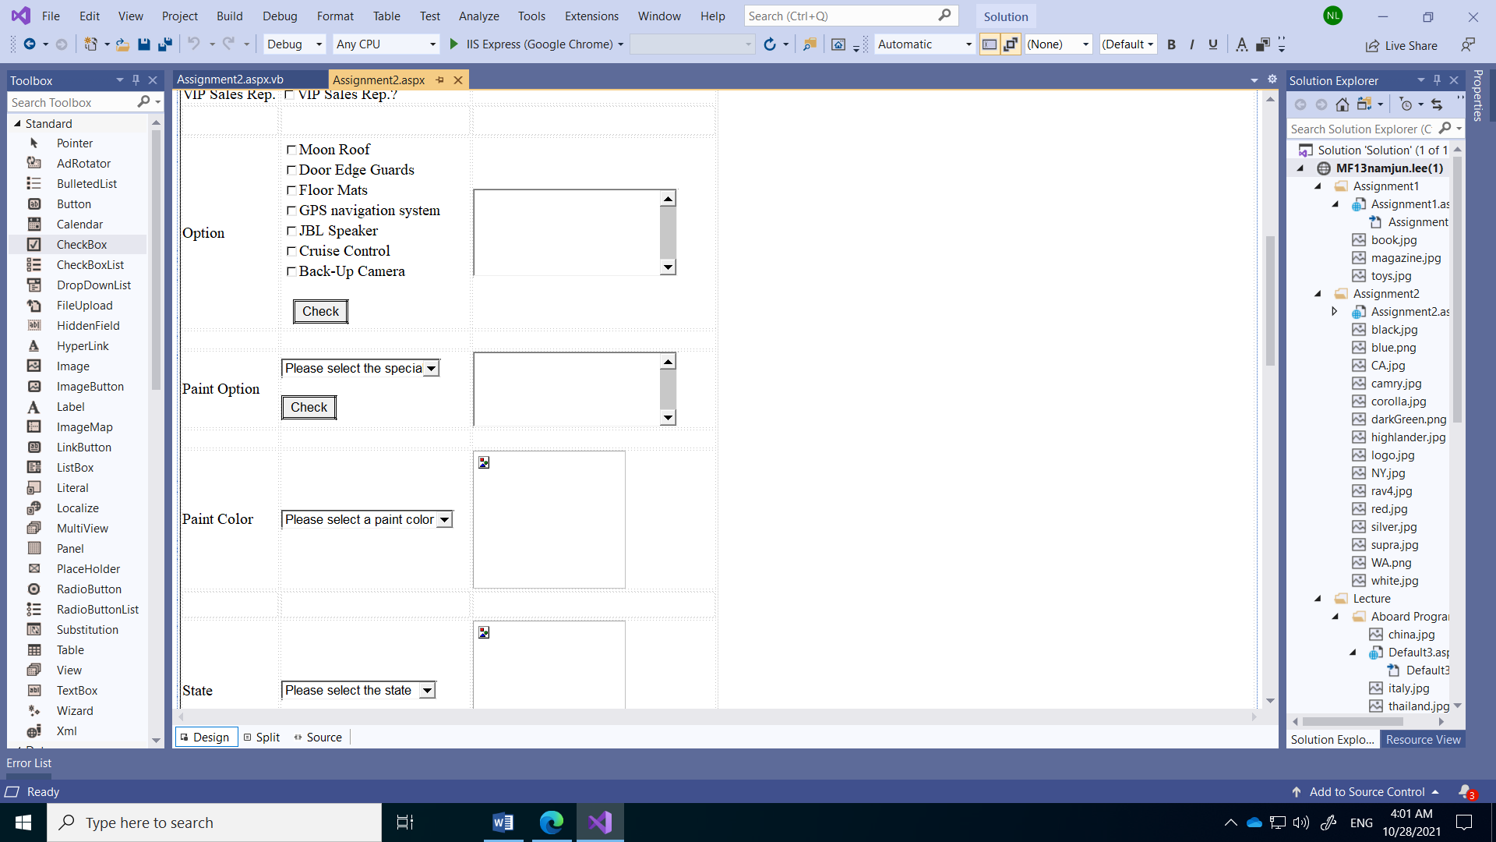

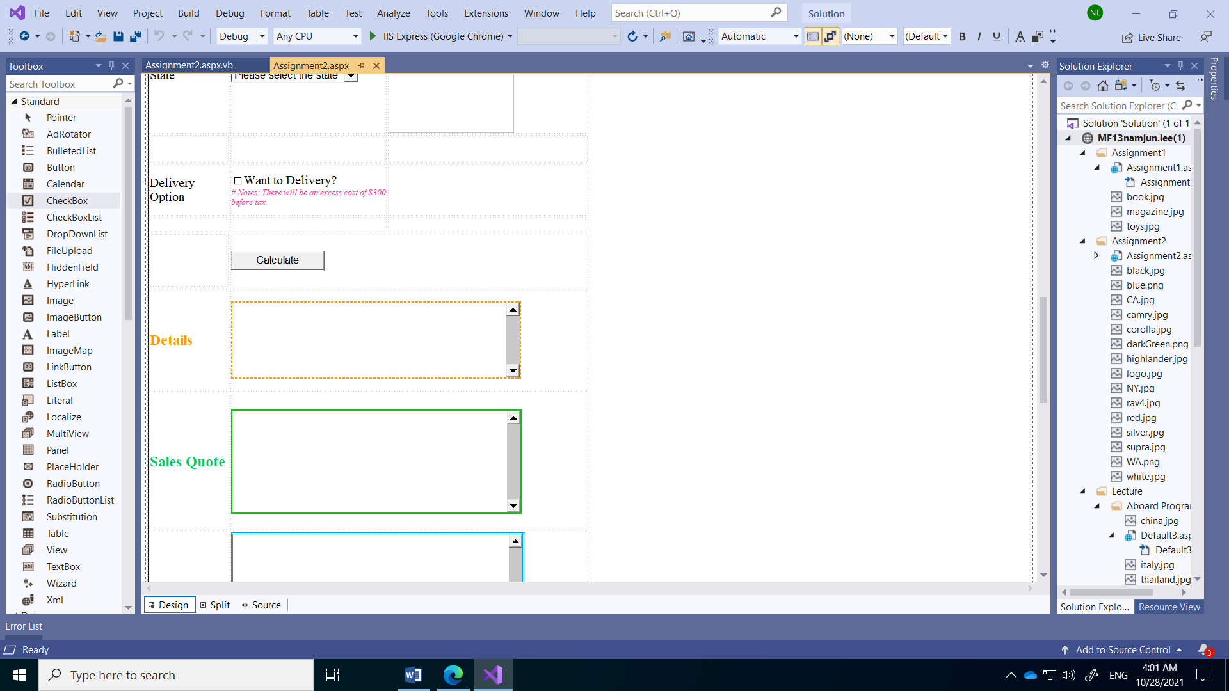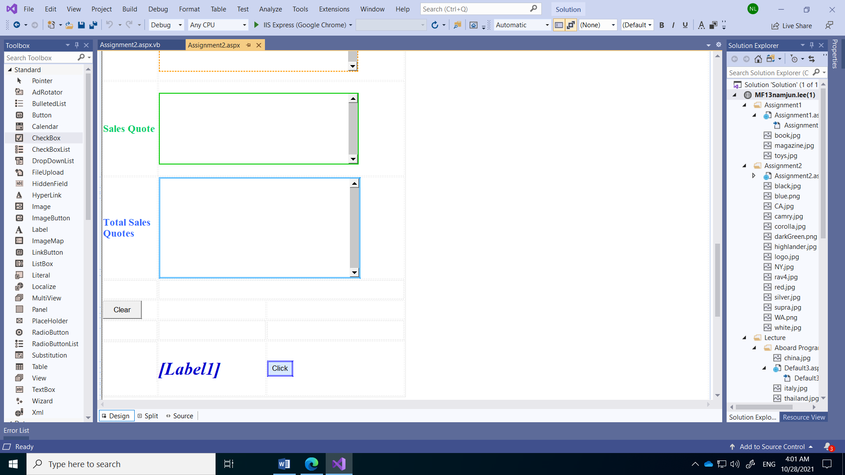

**Aspx.vb code:**

Partial Class Assignment2_Assignment2

Inherits System.Web.UI.Page

'This program is used to estimate the sales price of new cars and to calculate sales fees paid to salespeople who sell cars. Customers can add the options they want for the five Toyota cars and show the total cost, including taxes. When price quotation and sales are completed, the potential sales commission is shown (before tax). In addition, keep running the total to track and display the number of sales estimates you have made for each of the five cars.

'The six global integer variables are variables that count the number of quotes for each car, the total number of estimates for all cars quotes, and the number of customers who visited.

Public Shared gintRav4, gintCamry, gintCorolla, gintSupra, gintHighlander, gintQuoteNum, customerNum As Integer

'The six global decimal variables show the amount total quotes price by each car and also the total amount including taxes.

Public Shared gdecTotals, gdecRav4, gdecCamry, gdecCorolla, gdecSupra, gdecHighlander As Decimal

Protected Sub DropDownList1_SelectedIndexChanged(sender As Object, e As EventArgs) Handles DropDownList1.SelectedIndexChanged

'When a customer chooses a car model, it shows the image of each car.

MaintainScrollPositionOnPostBack = True

'Images are displayed differently depending on the selected vehicle type.

Select Case DropDownList1.SelectedItem.Text

Case "Rav4"

car.ImageUrl = "rav4.jpg"

Case "Camry"

car.ImageUrl = "camry.jpg"

Case "Corolla"

car.ImageUrl = "corolla.jpg"

Case "Supra"

car.ImageUrl = "supra.jpg"

Case "Highlander"

car.ImageUrl = "highlander.jpg"

End Select

End Sub

Protected Sub accButton_Click(sender As Object, e As EventArgs) Handles accButton.Click

'This button shows which option the customer has chosen when choosing an additional option for the car and displays each price.

MaintainScrollPositionOnPostBack = True

Dim opt As ListItem

Dim strOptions As String 'this variable used to build the list of opt

For Each opt In CheckBoxList1.Items 'for each item on the list of items for the checkbox. Run this loop once for each item on the list of opt. So 7 times. Use a loop to run code 7 times. Much more on loops another day.

If opt.Selected = True Then

strOptions &= opt.Text & ": $" & opt.Value & vbNewLine

End If

Next

'This shows the price for each option as to which option was selected in the txtOutputOpt multi line textbox.

txtOutputOpt.Text = "Selected options: " & vbNewLine & vbNewLine & strOptions

End Sub

Protected Sub paintButton_Click(sender As Object, e As EventArgs) Handles paintButton.Click

'This button indicates which option the customer has selected when selecting an additional paint option for the vehicle and indicates the additional price.

MaintainScrollPositionOnPostBack = True

'error check drop down list (not selected item).

If DropDownListPaintJob.SelectedIndex <= 0 Then

'If do not select an paint option, output a warning message to select one of the list.

txtOutputPaint.Text = "There are " & DropDownListPaintJob.Items.Count - 1 & " items on the list, please make a selection form the list"

Exit Sub

Else

'If the paint option is selected, it shows which option is selected and how much the additional amount is.

txtOutputPaint.Text = "Selected the " & DropDownListPaintJob.SelectedItem.Text & vbNewLine & vbNewLine & "Extra fee is $" & DropDownListPaintJob.SelectedValue

End If

End Sub

Protected Sub DropDownList2_SelectedIndexChanged(sender As Object, e As EventArgs) Handles DropDownListColor.SelectedIndexChanged

'When a customer decides the color of the vehicle, it shows an image of each color.

MaintainScrollPositionOnPostBack = True

'it have 6 colors in dorp down list

Select Case DropDownListColor.SelectedItem.Text

Case "Black"

paint.ImageUrl = "black.jpg"

Case "Blue"

paint.ImageUrl = "blue.png"

Case "Dark Green"

paint.ImageUrl = "darkGreen.png"

Case "Silver"

paint.ImageUrl = "silver.jpg"

Case "White"

paint.ImageUrl = "white.jpg"

Case "Red"

paint.ImageUrl = "red.jpg"

End Select

End Sub

Protected Sub DropDownListState_SelectedIndexChanged(sender As Object, e As EventArgs) Handles DropDownListState.SelectedIndexChanged

'This drop down list displays a flag image of the week when the customer selects one of the three states. It has different retail taxes on cars in each state.

MaintainScrollPositionOnPostBack = True

'it have 3 different state

Select Case DropDownListState.SelectedItem.Text

Case "Washington"

state.ImageUrl = "WA.png"

Case "California"

state.ImageUrl = "CA.jpg"

Case "New York"

state.ImageUrl = "NY.jpg"

End Select

End Sub

Protected Sub finalButton_Click(sender As Object, e As EventArgs) Handles finalButton.Click

'It serves to display in three multi-line text boxes of the selected vehicle. The first includes a vehicle and a model, a paint color, a special paint (option) and an accessory (option if desired). The second shows the vehicle sales quote for each car. Third, the total is continued to be executed to indicate the number of sales quotes prepared for each of the five cars.

MaintainScrollPositionOnPostBack = True

'This is a local decimal variables used to update the global variable at the top of this file.

Dim decTotal, decTax, decCommit, decAccPrice, decDiscount, decDelivery As Decimal

Dim strAc As ListItem

Dim strAcc As String 'this variable used to build the list of strAc

'Error checking DropDownList1 (car model)

If DropDownList1.SelectedIndex <= 0 Then

'If the customer does not choose, print a message at the top of the page and display three multi-line text boxes in red.

Response.Write("Please select a Model!!!!!!!!!!!!")

txtOutputDetail.BackColor = System.Drawing.Color.Red

txtOutputSales.BackColor = System.Drawing.Color.Red

txtOutputTotalQuote.BackColor = System.Drawing.Color.Red

Exit Sub

Else

'If the customer chooses, it works normally.

txtOutputDetail.BackColor = System.Drawing.Color.White

txtOutputSales.BackColor = System.Drawing.Color.White

txtOutputTotalQuote.BackColor = System.Drawing.Color.White

End If

'Add the selected car price to the total variable.

decTotal += DropDownList1.SelectedValue

For Each strAc In CheckBoxList1.Items

'for each item on the list of items for the checkbox. Run this loop once for each item on the list of car special paint option. So 7 times. Use a loop to run code 7 times. Much more on loops another day.

If strAc.Selected = True Then

decAccPrice += strAc.Value 'Add all the selected accessory prices to the accessory option variable.

decTotal += strAc.Value 'Add the total accessory price to the total variable.

strAcc &= "< " & strAc.Text & " > " 'display the list of accessory option

End If

Next

'Error checking DropDownListPaintJob (car special paint option)

If DropDownListPaintJob.SelectedIndex <= 0 Then

'If the customer does not choose, print a message at the top of the page and display three multi-line text boxes in red.

Response.Write("Please select a Special Paint!!!!!!!!!!!!!!!!")

txtOutputDetail.BackColor = System.Drawing.Color.Red

txtOutputSales.BackColor = System.Drawing.Color.Red

txtOutputTotalQuote.BackColor = System.Drawing.Color.Red

Exit Sub

Else

'If the customer chooses, it works normally.

txtOutputDetail.BackColor = System.Drawing.Color.White

txtOutputSales.BackColor = System.Drawing.Color.White

txtOutputTotalQuote.BackColor = System.Drawing.Color.White

End If

'Add the selected special paint value to the total variable.

decTotal += DropDownListPaintJob.SelectedValue

'Error checking DropDownListColor (car paint color option)

If DropDownListColor.SelectedIndex <= 0 Then

'If the customer does not choose, print a message at the top of the page and display three multi-line text boxes in red.

Response.Write("Please select a Paint Color!!!!!!!!!!!!!!!!")

txtOutputDetail.BackColor = System.Drawing.Color.Red

txtOutputSales.BackColor = System.Drawing.Color.Red

txtOutputTotalQuote.BackColor = System.Drawing.Color.Red

Exit Sub

Else

'If the customer chooses, it works normally.

txtOutputDetail.BackColor = System.Drawing.Color.White

txtOutputSales.BackColor = System.Drawing.Color.White

txtOutputTotalQuote.BackColor = System.Drawing.Color.White

End If

If CheckSpring.Checked = True Then

'If it is marked on the spring promotion check box, a 10 percent discount will be given from the total amount.

decDiscount = (decTotal * 0.1)

decTotal -= (decTotal * 0.1)

End If

If CheckVIP.Checked = True Then

'If it is marked on the VIP check box, it means that the salesperson has VIP salesperson status, so the fee is calculated at 1.5 %.

decCommit -= (decTotal * 0.015)

Else

'If the VIP check box is not marked, the fee will be calculated at 1.0 %.

decCommit -= (decTotal * 0.01)

End If

'Add one more piece of functionality of own design

If CheckBoxDelivery.Checked = True Then

'If marked then on the delivery check box, include $300 in the total amount.

decTotal += 300

decDelivery += 300

Else

'If not marked then on the delivery check box, set 0 in integer variable decDelivery.

decDelivery = 0

End If

'Error checking DropDownListState (state tax option)

If DropDownListState.SelectedIndex <= 0 Then

'If the customer does not choose, print a message at the top of the page and display three multi-line text boxes in red.

Response.Write("Please select a State!!!!!!!!!!!!!")

txtOutputDetail.BackColor = System.Drawing.Color.Red

txtOutputSales.BackColor = System.Drawing.Color.Red

txtOutputTotalQuote.BackColor = System.Drawing.Color.Red

Exit Sub

Else

'If the customer chooses, it works normally.

txtOutputDetail.BackColor = System.Drawing.Color.White

txtOutputSales.BackColor = System.Drawing.Color.White

txtOutputTotalQuote.BackColor = System.Drawing.Color.White

End If

'This Is a variable that shows how much tax Is.

decTax = (decTotal * DropDownListState.SelectedValue)

'It shows the total amount including tax.

decTotal += decTax

'This drop-down list shows the number of sales quote for each vehicle and the total number of sales quote price for each vehicle if the customer decides one of the five cars and receives an estimate.

Select Case DropDownList1.SelectedItem.Text

Case "Rav4"

'If the customer decides to Rav4, increase the number of estimates for this vehicle by one and add the amount of estimates for this vehicle to the gdecRav4 variable.

gintRav4 += 1

gdecRav4 += decTotal

Case "Camry"

'If the customer decides to Camry, increase the number of estimates for this vehicle by one and add the amount of estimates for this vehicle to the gdecCamry variable.

gintCamry += 1

gdecCamry += decTotal

Case "Corolla"

'If the customer decides to Corolla, increase the number of estimates for this vehicle by one and add the amount of estimates for this vehicle to the gdecCorolla variable.

gintCorolla += 1

gdecCorolla += decTotal

Case "Supra"

'If the customer decides to Supra, increase the number of estimates for this vehicle by one and add the amount of estimates for this vehicle to the gdecSupra variable.

gintSupra += 1

gdecSupra += decTotal

Case "Highlander"

'If the customer decides to Highlander, increase the number of estimates for this vehicle by one and add the amount of estimates for this vehicle to the gdecHighlander variable.

gintHighlander += 1

gdecHighlander += decTotal

End Select

gintQuoteNum += 1 'It shows the total number of sales quotes.

gdecTotals += decTotal 'It shows the total sales quotes price of all cars.

customerNum += 1 'It shows how many customers requested.

'show the first output on webpage; it includes a vehicle and a model, a paint color, a special paint (option) and an accessory (option if desired).

txtOutputDetail.Text = "Customer " & customerNum.ToString & " selected:" & vbNewLine & vbNewLine & "[Model] " & DropDownList1.SelectedItem.Text & vbNewLine & vbNewLine & "[Accessory Option] " & strAcc & vbNewLine & vbNewLine & "[Special Paint] " & DropDownListPaintJob.SelectedItem.Text & vbNewLine & vbNewLine & "[Paint Color] " & DropDownListColor.SelectedItem.Text & vbNewLine

'show the second output on webpage; it includes the vehicle sales quote for each car.

txtOutputSales.Text = "*** Sales Quote " & gintQuoteNum.ToString & " ***" & vbNewLine & vbNewLine & "Car Price: $" & DropDownList1.SelectedValue & vbNewLine & "Selection Option Price: " & decAccPrice.ToString("C0") & vbNewLine & "Selection Special Paint Price: $" & DropDownListPaintJob.SelectedValue & vbNewLine & "Delivery Fee: " & decDelivery.ToString("C0") & vbNewLine & "Discount Price: (-)" & decDiscount.ToString("C0") & vbNewLine & DropDownListState.SelectedItem.Text & " Sales Tax: " & decTax.ToString("C0") & vbNewLine & vbNewLine & "[ Total Prices: " & decTotal.ToString("C0") & " ]" & vbNewLine & vbNewLine & "Commission for Sales: " & decCommit.ToString("C0")

'show the third output on webpage; it includes the total is continued to be executed to indicate the number of sales quotes prepared for each of the five cars.

txtOutputTotalQuote.Text = "Daily Total Sales Quotes (count): " & gintQuoteNum & vbNewLine & "Daily Total Sales Quotes (price): " & gdecTotals.ToString("C0") & vbNewLine & vbNewLine

txtOutputTotalQuote.Text &= "[Rav4]" & vbNewLine & "Quantity of Sales Quote: " & gintRav4 & vbNewLine & "Price of Sales Quote: " & gdecRav4.ToString("C0") & vbNewLine & vbNewLine

txtOutputTotalQuote.Text &= "[Camry]" & vbNewLine & "Quantity of Sales Quote: " & gintCamry & vbNewLine & "Price of Sales Quote: " & gdecCamry.ToString("C0") & vbNewLine & vbNewLine

txtOutputTotalQuote.Text &= "[Corolla]" & vbNewLine & "Quantity of Sales Quote: " & gintCorolla & vbNewLine & "Price of Sales Quote: " & gdecCorolla.ToString("C0") & vbNewLine & vbNewLine

txtOutputTotalQuote.Text &= "[Supra]" & vbNewLine & "Quantity of Sales Quote: " & gintSupra & vbNewLine & "Price of Sales Quote: " & gdecSupra.ToString("C0") & vbNewLine & vbNewLine

txtOutputTotalQuote.Text &= "[Highlander]" & vbNewLine & "Quantity of Sales Quote: " & gintHighlander & vbNewLine & "Price of Sales Quote: " & gdecHighlander.ToString("C0") & vbNewLine

End Sub

Protected Sub clear_Click(sender As Object, e As EventArgs) Handles clear.Click

'clear the all output text boxes, check boxes, images, list cotrols on webpage'

'set output multi line text boxes nothing

txtOutputDetail.Text = Nothing

txtOutputOpt.Text = Nothing

txtOutputPaint.Text = Nothing

txtOutputSales.Text = Nothing

txtOutputTotalQuote.Text = Nothing

'set list controls index -1

DropDownList1.SelectedIndex = -1

DropDownListColor.SelectedIndex = -1

DropDownListPaintJob.SelectedIndex = -1

DropDownListState.SelectedIndex = -1

CheckBoxList1.SelectedIndex = -1

'set check boxes checked false

CheckBoxDelivery.Checked = False

CheckSpring.Checked = False

CheckVIP.Checked = False

'set image nothing

car.ImageUrl = Nothing

paint.ImageUrl = Nothing

state.ImageUrl = Nothing

'set text box nothing

Label1.Text = Nothing

End Sub

Protected Sub Click_Click(sender As Object, e As EventArgs) Handles Click.Click

'Click this button to output label characters on the screen.

MaintainScrollPositionOnPostBack = True

Label1.Text &= "Thank You !!!"

End Sub

End Class

Run my webpage:

